Torrodjae Somerville
CTEC 298-101 Symbolic Computation Using Big Data
Dr. Bemley
Learn Python Tutorial Part 1
10/17/2025

- “Hello World” tutorial completion screen
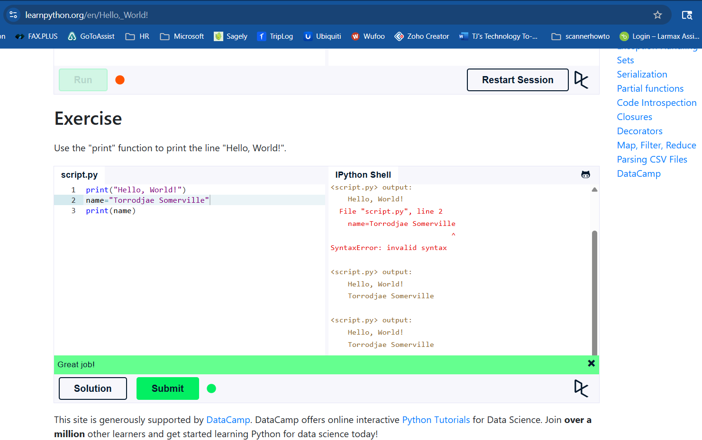

Full Code: print("Hello, World!")
name = "Torrodjae Somerville"
print(name)

- “Variables and Types” completion screen
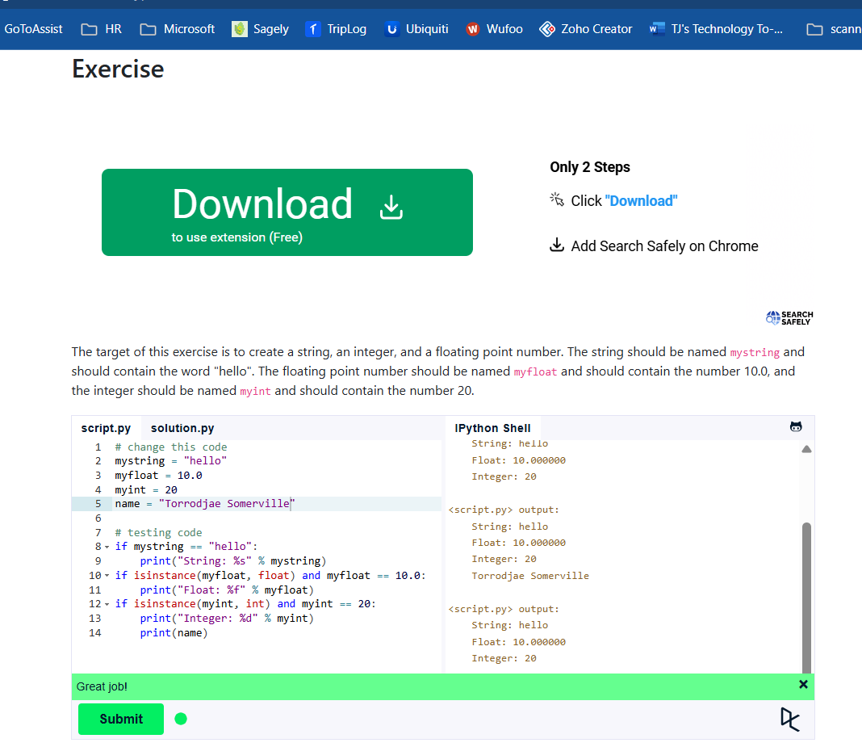
Full Code:# change this code
mystring = "hello"
myfloat = 10.0
myint = 20
name = "Torrodjae Somerville"

# testing code
if mystring == "hello":
print("String: %s" % mystring)
if isinstance(myfloat, float) and myfloat == 10.0:
print("Float: %f" % myfloat)
if isinstance(myint, int) and myint == 20:
print("Integer: %d" % myint)
print(name)
- “Lists” tutorial completion screen
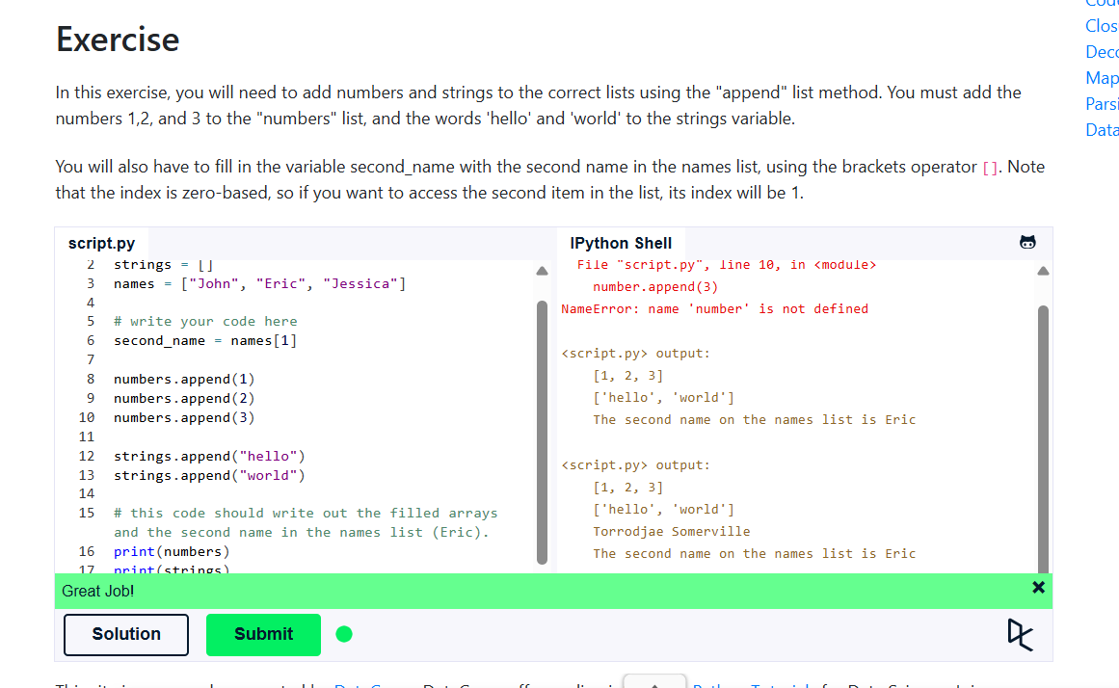
Full code: numbers = []
strings = []
names = ["John", "Eric", "Jessica"]

# write your code here
second_name = names[1]

numbers.append(1)
numbers.append(2)
numbers.append(3)

strings.append("hello")
strings.append("world")
# this code should write out the filled arrays and the second name in the names list (Eric).
print(numbers)
print(strings)
print("The second name on the names list is %s" % second_name)
print("Torrodjae")

- “Basic Operators” tutorial completion screen
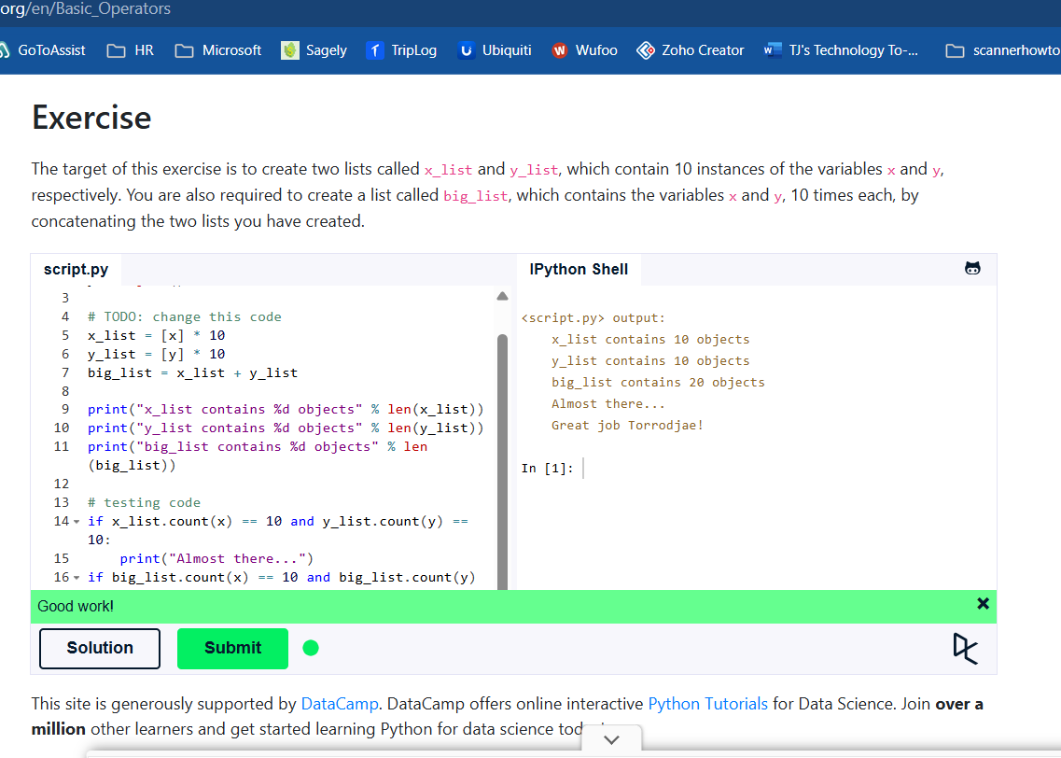
Full Code: x = object()
y = object()

# TODO: change this code
x_list = [x] * 10
y_list = [y] * 10
big_list = x_list + y_list

print("x_list contains %d objects" % len(x_list))
print("y_list contains %d objects" % len(y_list))
print("big_list contains %d objects" % len(big_list))

# testing code
if x_list.count(x) == 10 and y_list.count(y) == 10:
print("Almost there...")
if big_list.count(x) == 10 and big_list.count(y) == 10:
print("Great job Torrodjae!")

- “String Formatting” tutorial completion screen
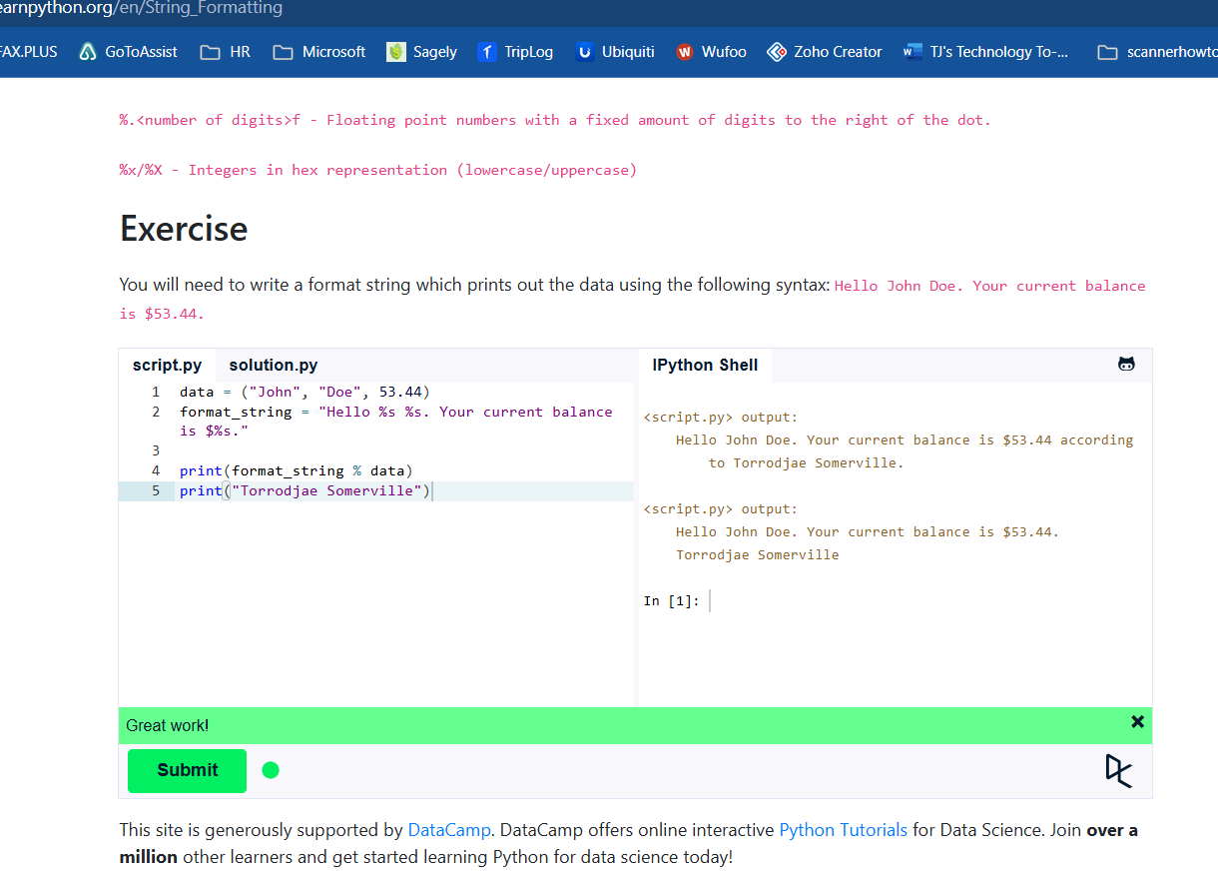
Full Code: data = ("John", "Doe", 53.44)
format_string = "Hello %s %s. Your current balance is $%s."

print(format_string % data)
print("Torrodjae Somerville")

- “Basic String Operations” tutorial completion screen
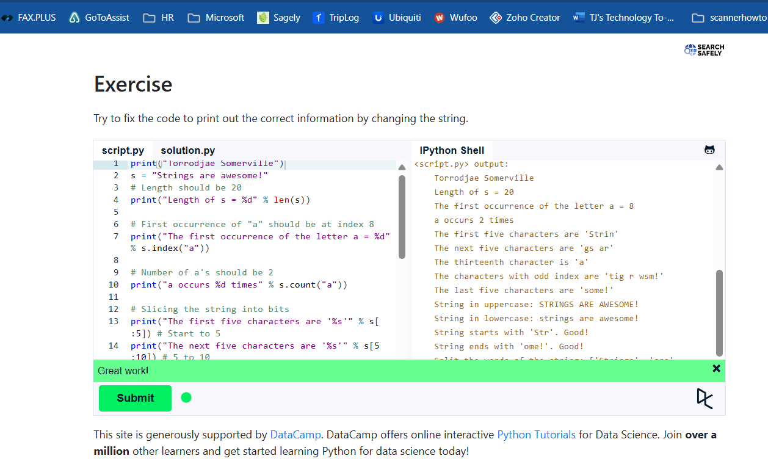
Full Code: print("Torrodjae Somerville")
s = "Strings are awesome!"
# Length should be 20
print("Length of s = %d" % len(s))

# First occurrence of "a" should be at index 8
print("The first occurrence of the letter a = %d" % s.index("a"))

# Number of a's should be 2
print("a occurs %d times" % s.count("a"))

# Slicing the string into bits
print("The first five characters are '%s'" % s[:5]) # Start to 5
print("The next five characters are '%s'" % s[5:10]) # 5 to 10
print("The thirteenth character is '%s'" % s[12]) # Just number 12
print("The characters with odd index are '%s'" %s[1::2]) #(0-based indexing)
print("The last five characters are '%s'" % s[-5:]) # 5th-from-last to end

# Convert everything to uppercase
print("String in uppercase: %s" % s.upper())

# Convert everything to lowercase
print("String in lowercase: %s" % s.lower())

# Check how a string starts
if s.startswith("Str"):
print("String starts with 'Str'. Good!")

# Check how a string ends
if s.endswith("ome!"):
print("String ends with 'ome!'. Good!")

# Split the string into three separate strings,
# each containing only a word
print("Split the words of the string: %s" % s.split(" "))

